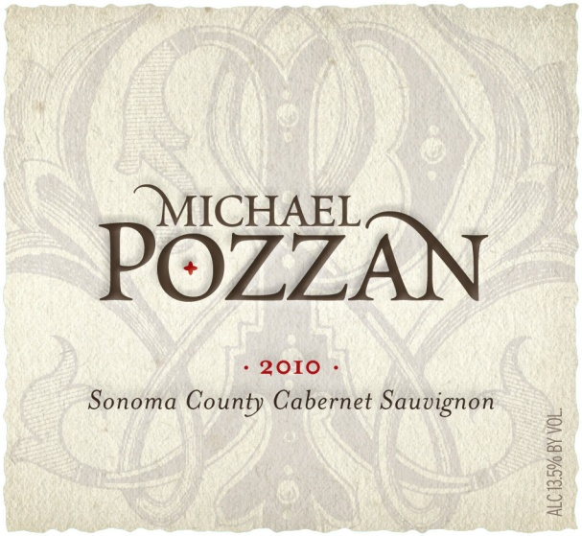

Michael Pozzan
2010 Cabernet Sauvignon

Technical Analysis:
Varietal Cabernet Sauvignon (100%)
Appellation Alexander Valley 60%, Dry Creek Valley 40%
Alcohol 13.5%
Aging 24 Months in French Oak
Production 5,000 cases

Tasting Notes:
This is a serious Cabernet Sauvignon with a dark plum color. The palate is rich with mocha and cassis, backed with ripe cherry. It is a super extracted wine featuring huckleberry concentrate, brown sugar with roasted coffee and hazelnut notes. There is an underlying sweet oak flavor from extensive barrel aging and the wine finishes with a long, supple, sappy French oak finish.

This wine is a must with a mushroom crusted, seared filet mignon and a plum truffle sauce, served with English peas and saffron infused Maui gold mashed potatoes.

This wine drinks well now, but will mature well with further cellaring through 2025 and perhaps beyond.

